Review for Test 1
This is just a quick note for the homework. Please double-check the textbook before using it.

Chapter 2: Dimensions and Fundamentals

Example 2-1:
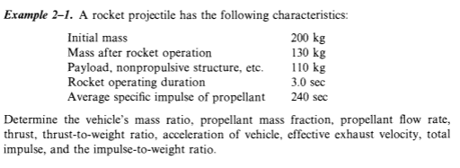
- Mass ratio:
(mf: the final mass of the vehicle after the rocket has ceased to operate, 130-110; m0: mass before the rocket operation, 200-110)
- Propellant mass fraction: 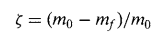
- Propellant flow rate: propellant mass / operation duration.
- Thrust: 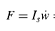
- Effective exhaust velocity
- Total impulse: 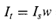

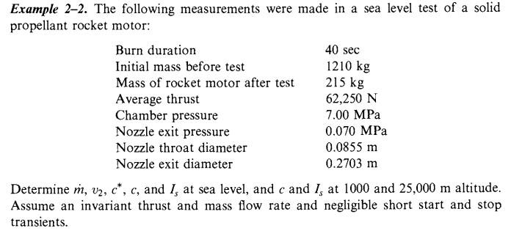(1) Mass flow rate: Total propellant used / duration time = (initial mass-final mass) / time
(2) Exit velocity v2: 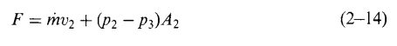

(3) Characteristic velocity c*: 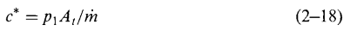
(4) Effective exhaust velocity:
(5) Specific impulse: 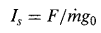
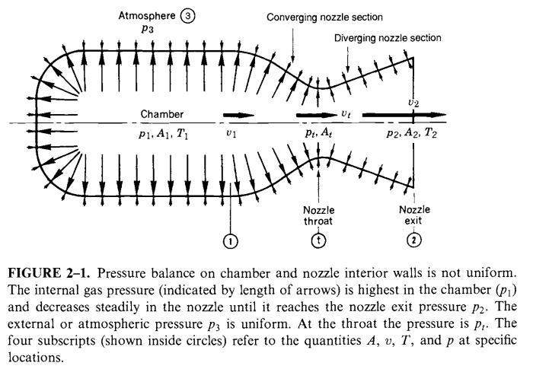
Homework #3 (solved in metric in python & Excel)
Plot the variable of “Thrust” and “Specific Impulse” against “Altitude”, using the atmospheric pressure information in the Appendix of your textbook. Use the “Minuteman” first-stage rocket engine information as follows:
- P₂ = 8.66 psia (assume to remain constant with altitude)
- Sea-Level Thrust, F = 194,600 lb
- Sea-Level Specific Impulse, I_{sp} = 254 seconds
- A₂ = 1,642 in^2
(1) and (2): Calculate effective exit velocity c and propellant mass flow m-dot:
(3) Calculate weight flow rate w-dot:
w-dot=m-dot * g0
(4) Calculate exit velocity v2 at sea level: 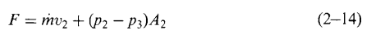

Chapter 3: NOZZLE THEORY AND THERMODYNAMIC RELATIONS
HW#4:
(1) Reproduce Figure 3-1 when k=1.3. (The details is in Ch.3 Slides-1)
(2) Redo Example 3-1.
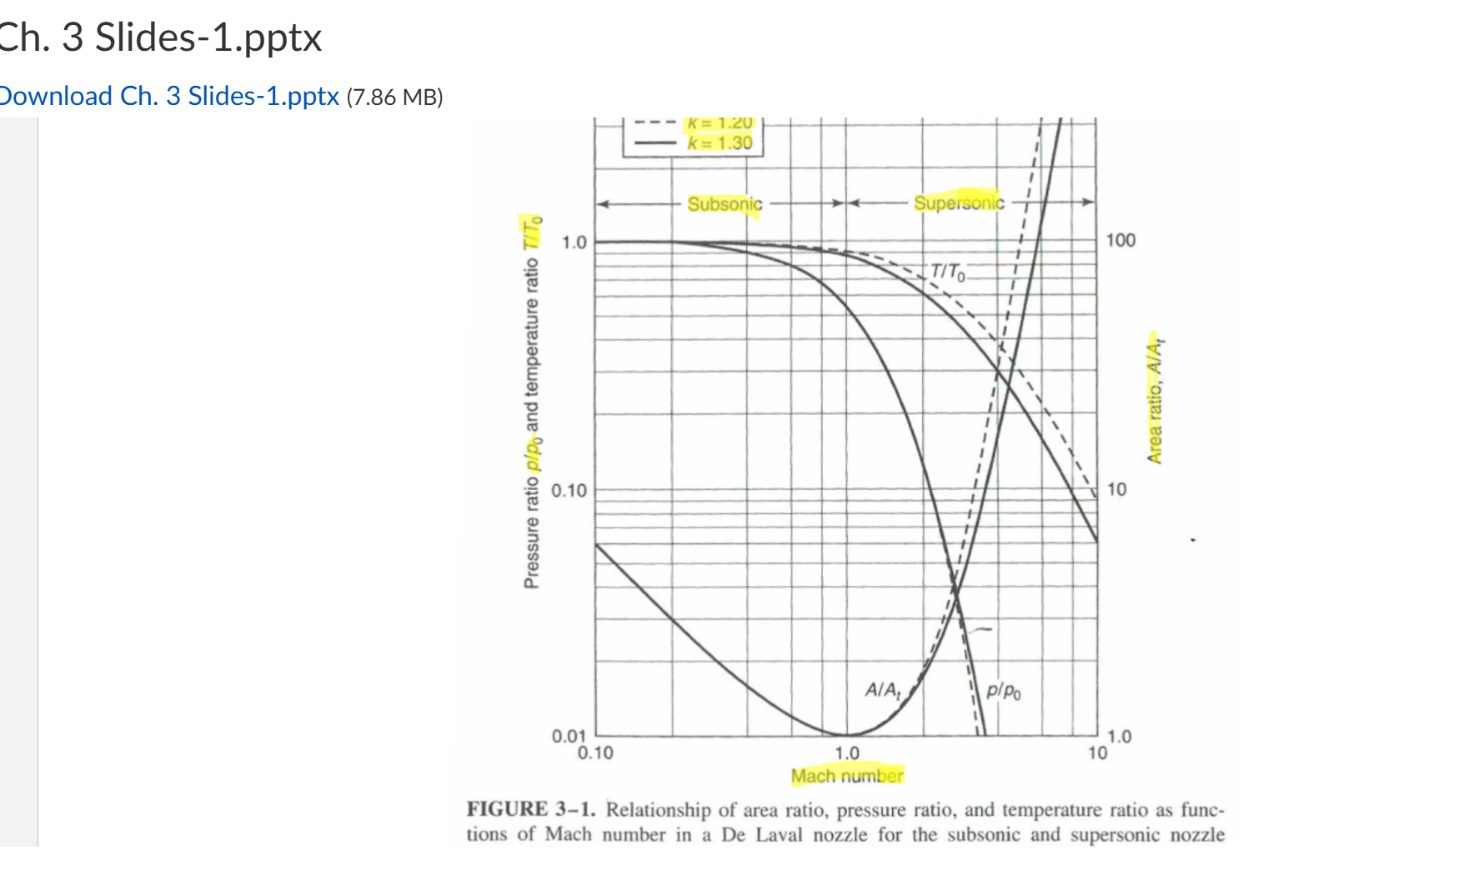
Isentropic relations:
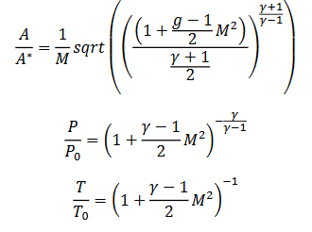
For optimum expansion:
- Nozzle exit pressure = ambient pressure
- Chamber pressure $≈$ total pressure
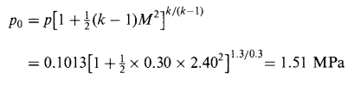
Nozzle area ratio between the throat and exit can be calculated when M=1.

HW#5: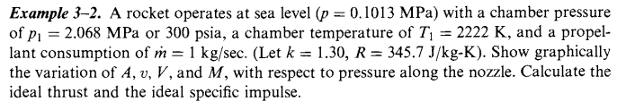
- Initial specific volume from the perfect gas law:
- The specific volume at pressure of Px from isentropic flow process:
Or 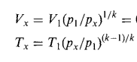
- Exhaust velocity v2: 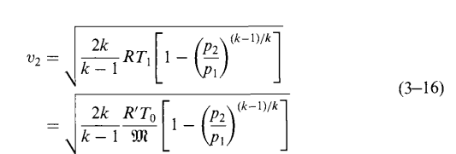
- Cross section area from the principle of mass conservation:
- Mach number: 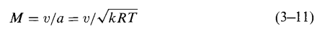
- Thrust and impulse: 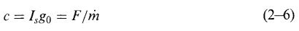
HW#6
Generate Fig. 3-4
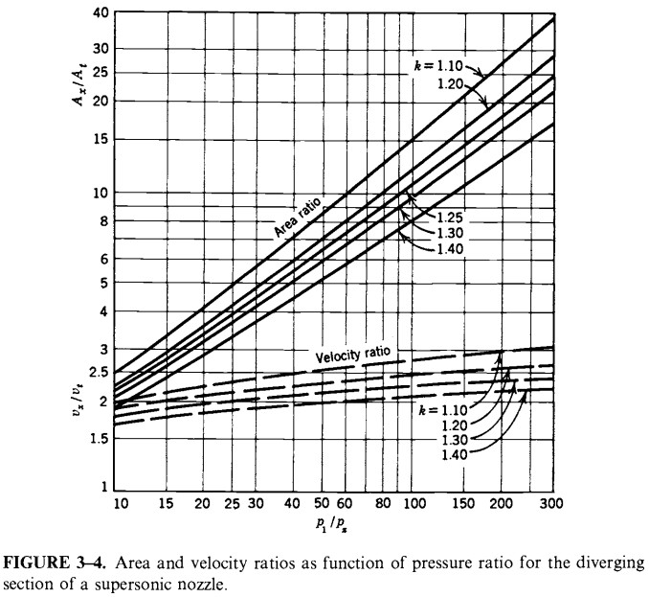
Area ratio (3-25) :
The ratio between the throat and any downstream area at which a pressure px prevails can be expressed as:
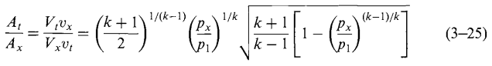Velocity ratio (3-26)
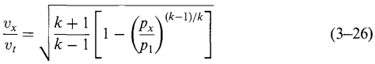

HW#7
Example 3-3:
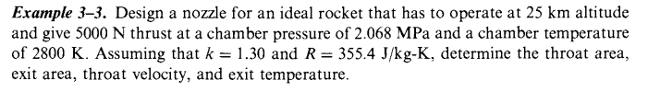
- Critical (or throat) pressure:
- Critical (or throat) velocity: 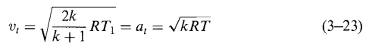
- Ideal exit velocity: 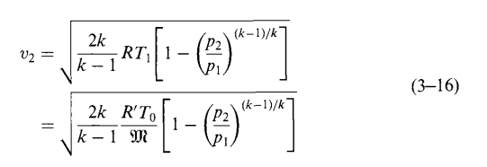
- Ideal propellant consumption for optimum expansion condition: 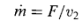
- Specific volume at the entrance to the nozzle: 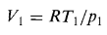
- Specific volume at the throat:
- Specific volume at the exit for the isentropic flow process:
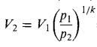
- The area at the throat and exit:
(where v is velocity and V is specific volume)
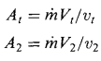
- Nozzle area ratio (The ratio of the nozzle exit area A2 to the throat area At):
- Exit temperature (for an isentropic flow process) :
